Pittsburgh Pride March & Parade

Sunday, June 1, 2025

Learn more at https://pittsburghpride.com/
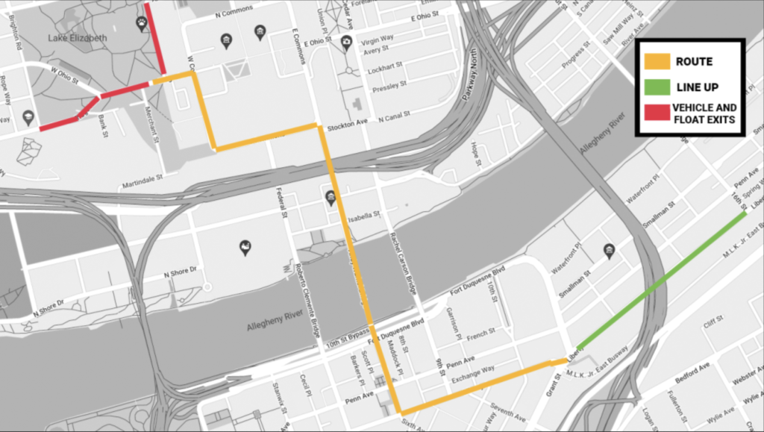
Line up for the march and parade will begin at 10:00 AM at 11th and 16th Streets in the Strip District. LAMP will meet at the white van that says, “East Liberty Presbyterian Church” to march together. Stepping off at noon, from 11th Street at Liberty Avenue the parade will proceed down Liberty Ave towards 7th Street, turn right on 7th Street and continue across the Andy Warhol Bridge, continue on Sandusky Street, turn left on to South Commons and proceed to Allegheny Commons Park West for the Pittsburgh Pride Festival (which is from 1PM-9PM). Sign up to volunteer at the booth with other LAMP and ELPC folks at https://www.signupgenius.com/go/10C0E48ADAB2DA4FAC25-56672328-pride.

Pittsburgh Black Pride @ ELPC
Saturday, July 26, 2025 - Family Fun Day
Learn more at https://cathedralofhope.org/event/family-fun-day-with-pittsburgh-black-pride/
All are welcome to this Family Fun Day co-hosted by Pittsburgh Black Pride, ELPC’s Justice Committee, and ELPC’s LGBTQIA+ Ministry as we share fellowship, food, and fun as this event returns to ELPC – including a 3on3 basketball tournament, a talent show, bowling, face painting, jewelry making, and much more. This is a free event open to the public going 12-4pm. Come visit with current friends and make some new ones!
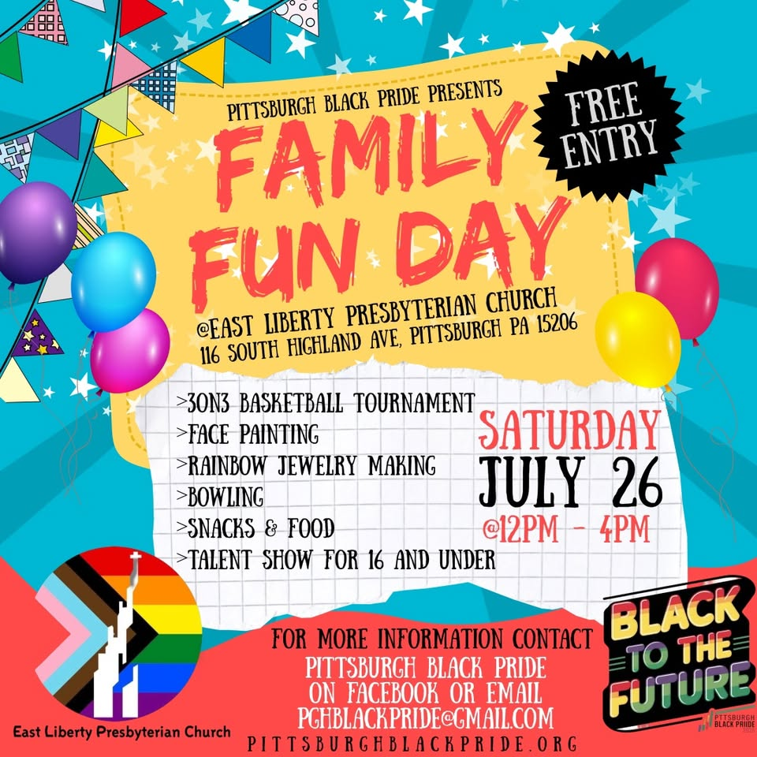
A Sampling of Other 2025 Pittsburgh Area Prides
While ELPC and LAMP will not be marching and hosting tables at these area events, you are encouraged to reflect God’s love in these areas and all around Pittsburgh!

Ross Pride: Sunday, June 8: https://www.facebook.com/events/1064083912194657

Mt. Lebanon Pride: Sat, June 14: https://lebopride.org/event/annual-celebration-2025/

Millvale Pride: Saturday, June 14: https://www.pridemillvale.org/

Fox Chapel Pride: Sunday, June 29: https://www.fcprideinthepark.com/

Forest Hills Pride: Sun, June 29: https://www.facebook.com/profile.php?id=61558811993547

Disability Pride Pittsburgh: Saturday, Aug 24: https://www.disabilitypridepa.org/dp-pgh

Black Pride Pittsburgh: https://www.pghblackpride.org/

